**Spring Fundamentals**

# Course Overview

## Course Overview

# Introduction

## Introduction

## What is Spring?

## Update

## The Problem

## Business Focus

## The Solution

## Business Focus Revisited

## How It Works

## Summary

# Architecture and Project Setup

## Sample App Intro

## Architecture

## Prerequisites

## Sample App Setup

## Sample App pom.xml Demo

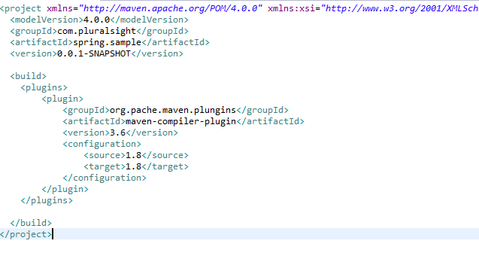

## Sample App Add Model Demo

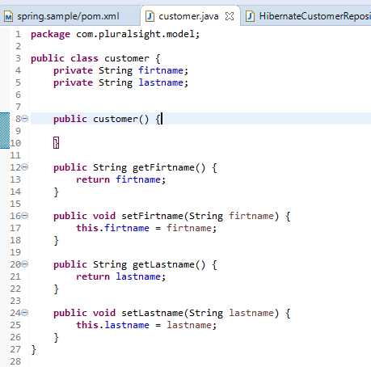

## Sample App Add Repository Demo

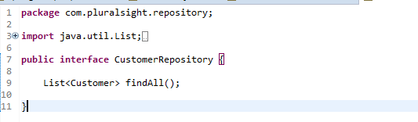

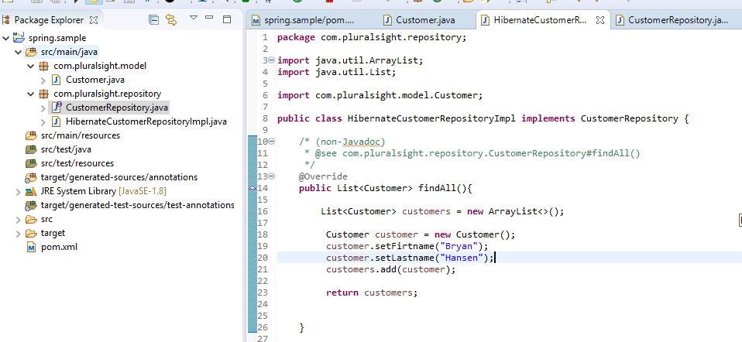

## Sample App Add Service Demo

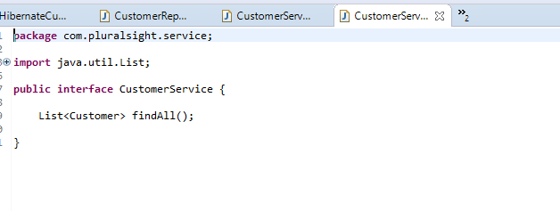

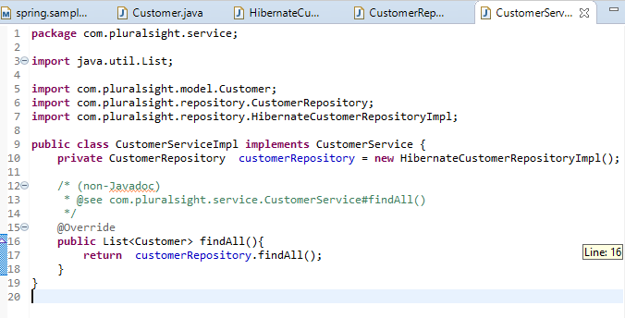

## Sample App Run Application Demo

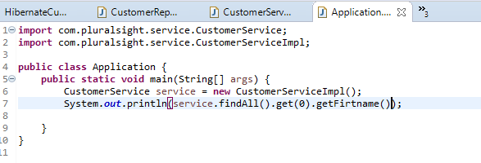

## Configuration

## Pain Points Walkthrough Demo

## Spring Download

## Spring Download Maven Demo

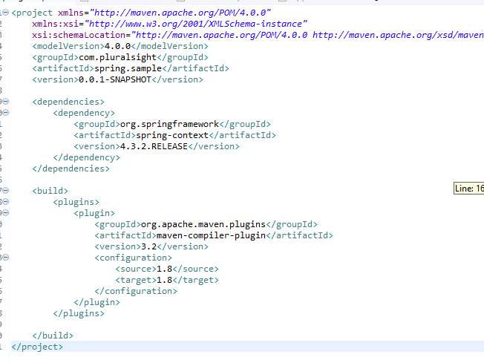

## Summary

# Spring XML Configuration

## XML Config Introduction

## Why Use XML?

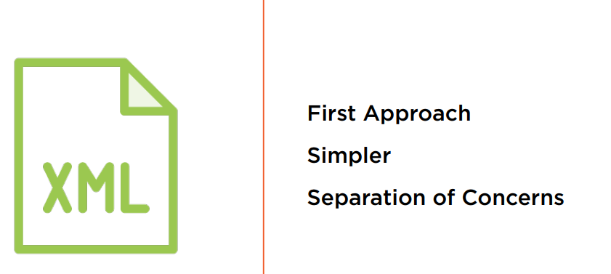

## Copy Demo

## Application Context

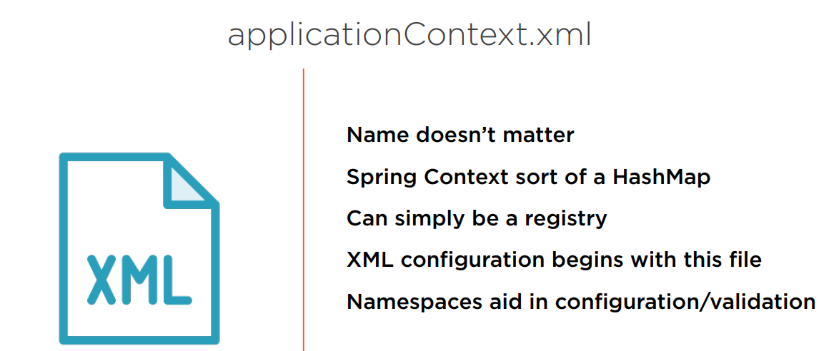

## Application Context Demo

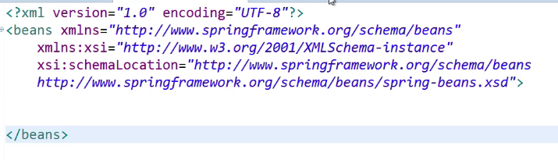

## Namespaces

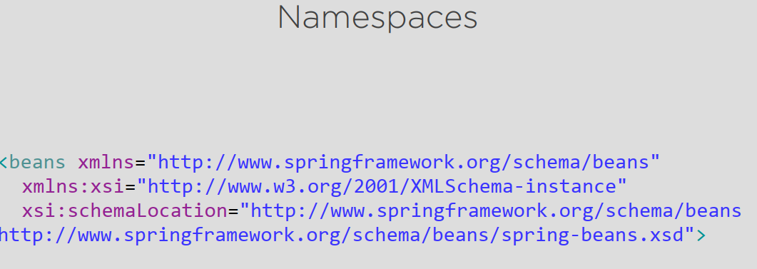

## XML Declaration

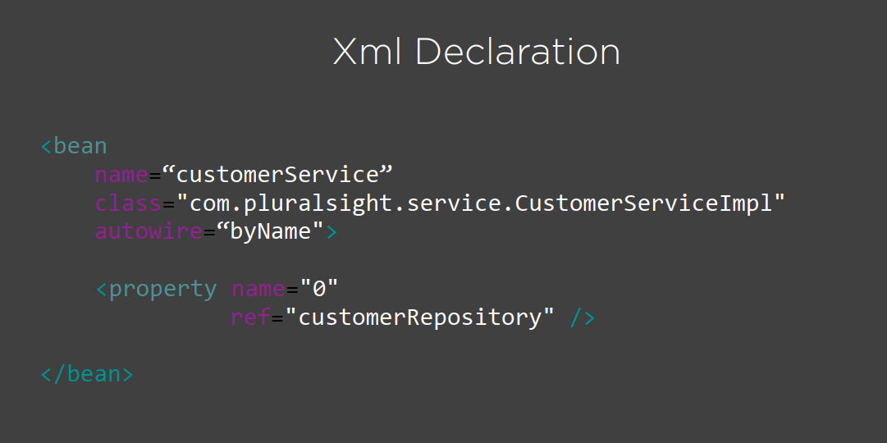

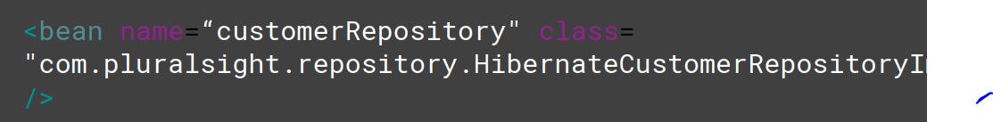

## Beans

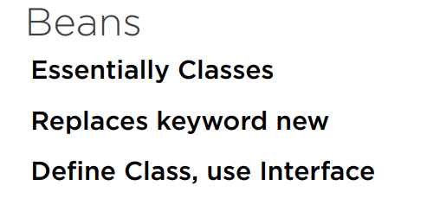

## Bean Demo

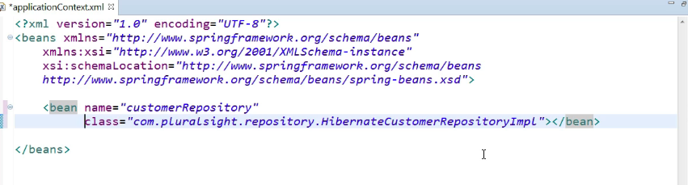

## Setter Injection

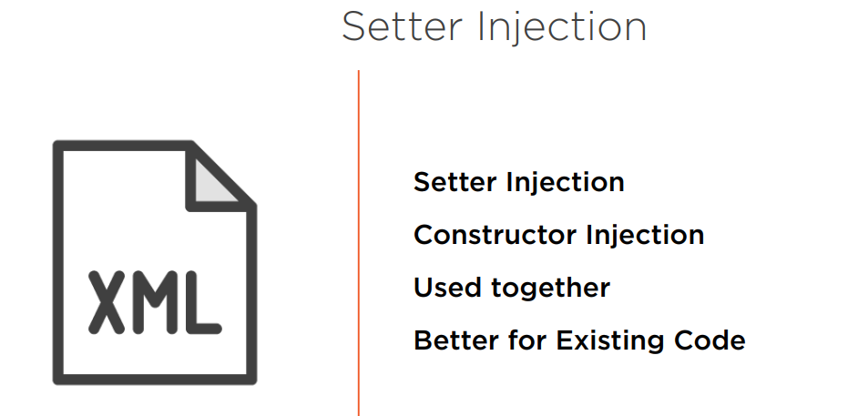

## Setter Injection Demo

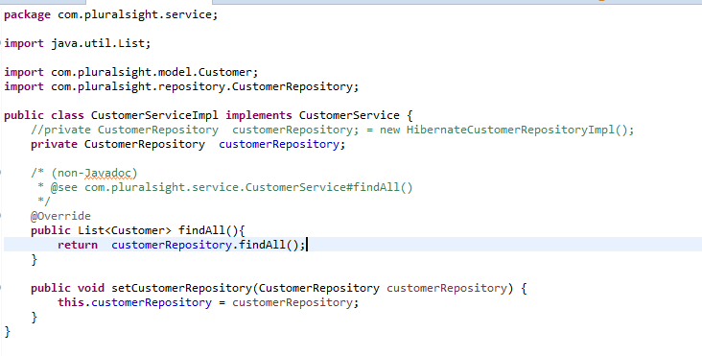

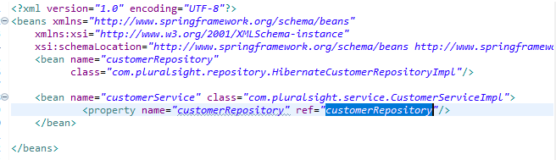

Name interface

Name class implements

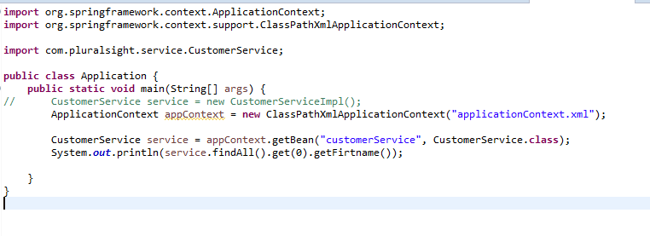

## Constructor Injection

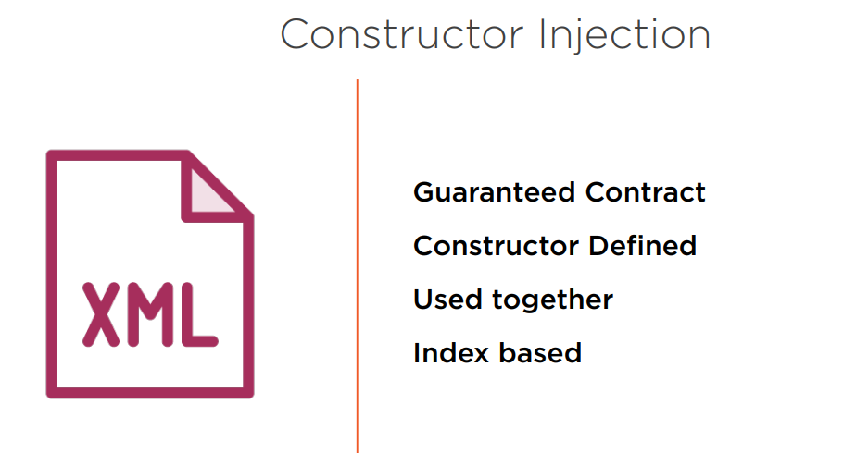

## Constructor Injection Demo

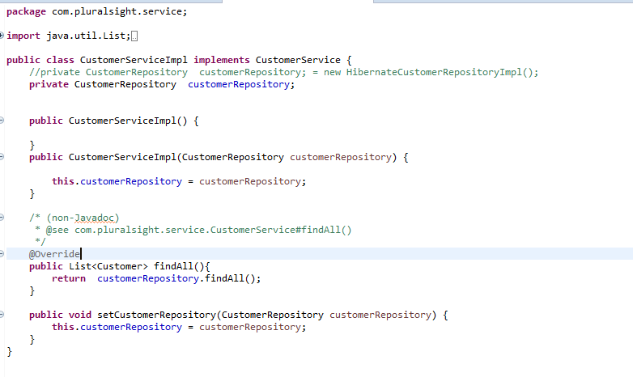

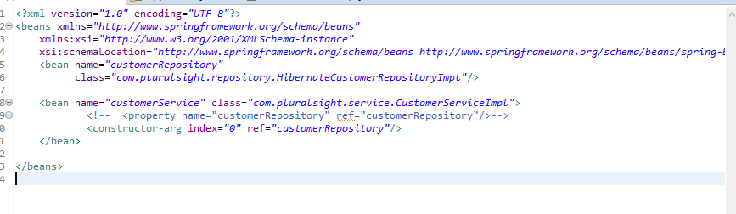

## Autowire

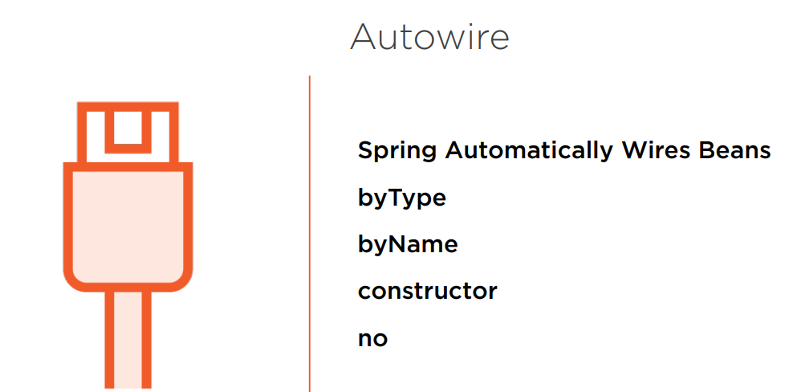

## Autowire by Constructor Demo

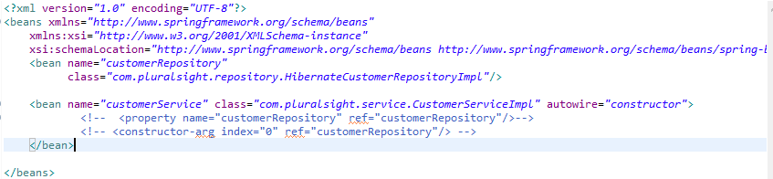

## Autowire by Name and Type Demo

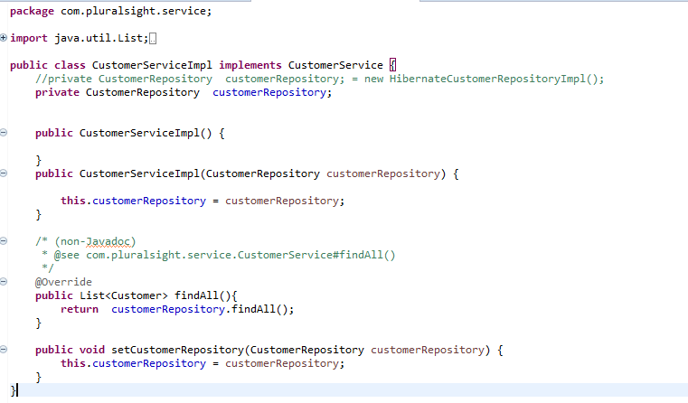

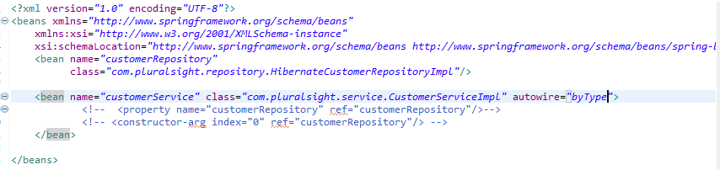

If set in serviceImpl the same name in bean repositoryImpl => in bean ServiceImpl can use autowire “byType”, “byName”

## Summary

# Spring Annotation Configuration Using XML

## Annotation Config

## Copy Demo

## Application Context

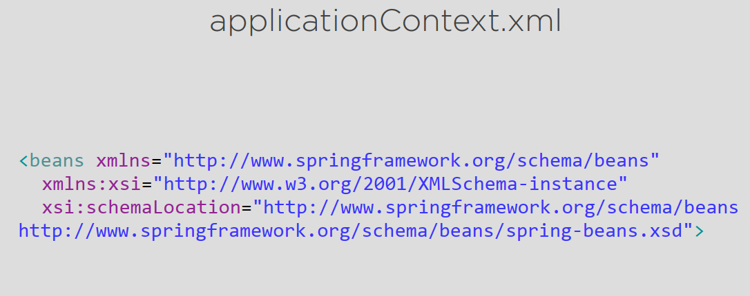

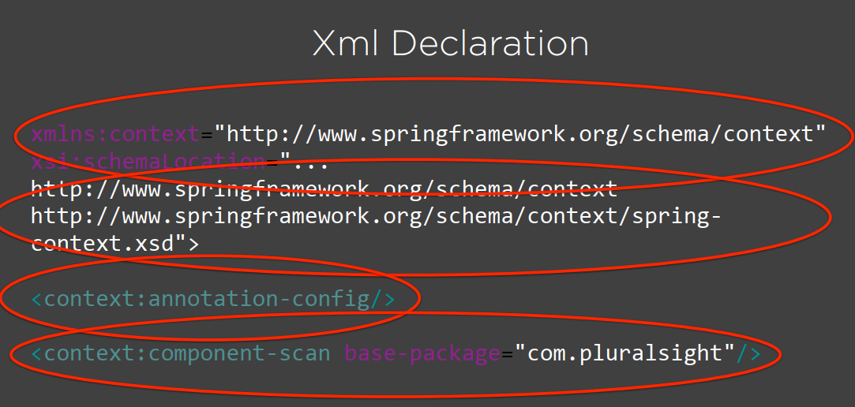

## Application Context Demo

## Component Scanner

## Component Scanner Demo

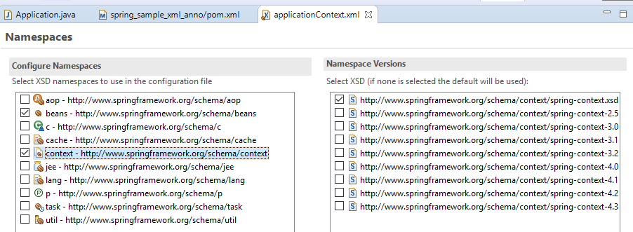

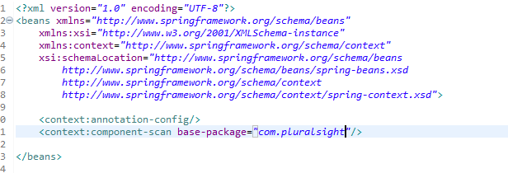

## Stereotype Annotations

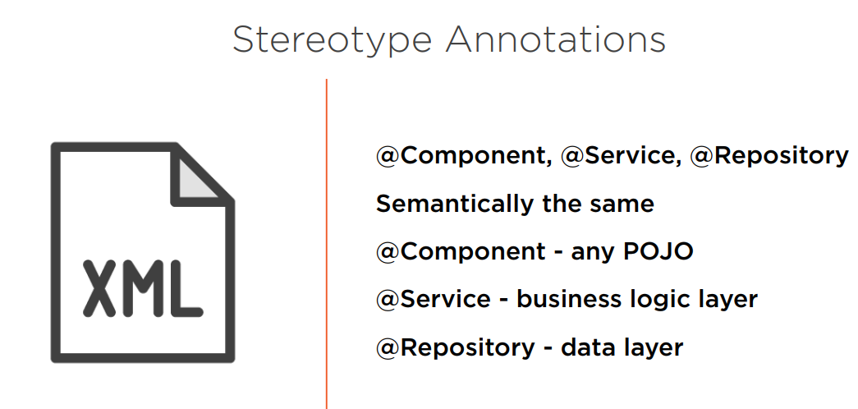

## Stereotype Annotations Demo

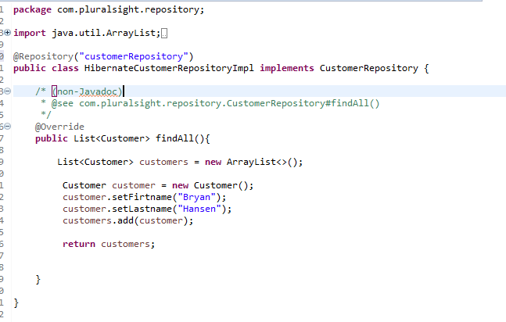

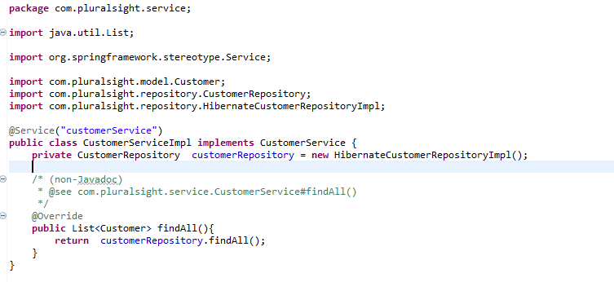

## Autowired

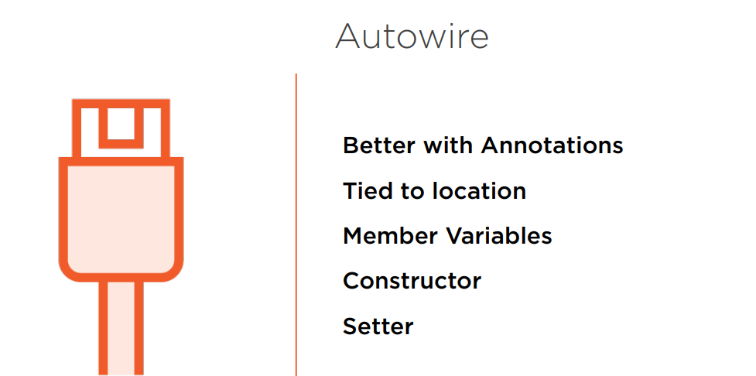

## Autowire Member

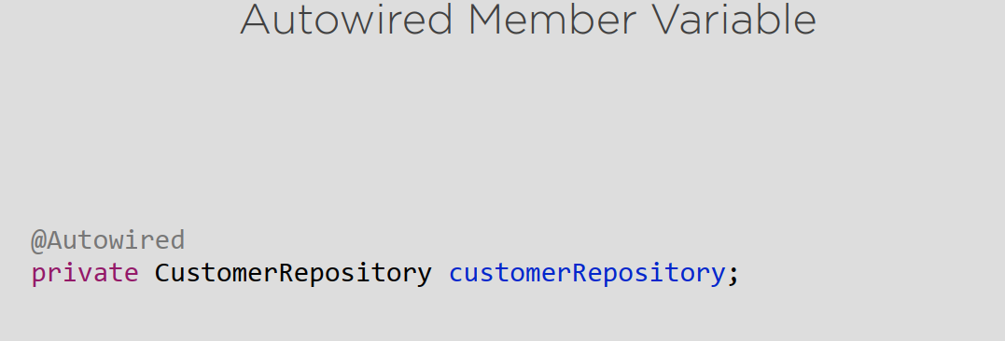

## Member Injection Demo

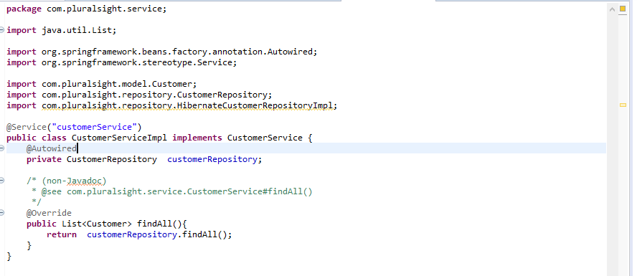

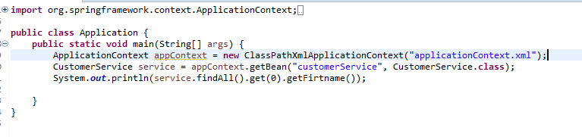

## Setter Injection

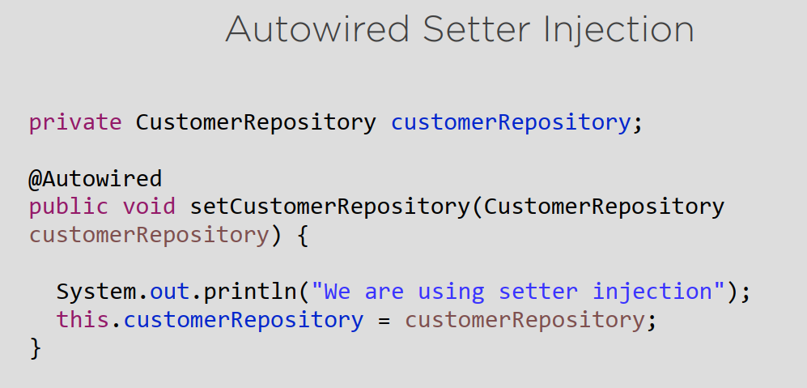

## Setter Injection Demo

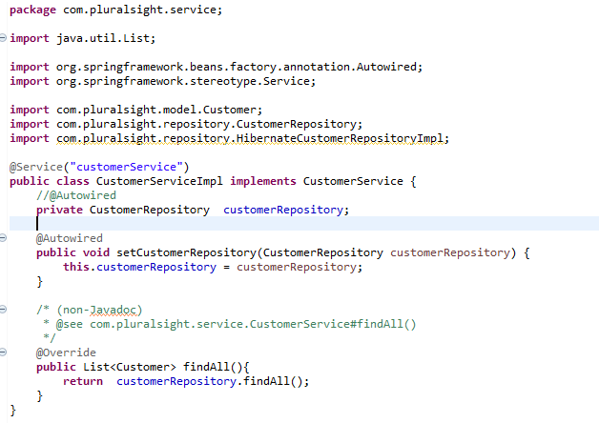

## Constructor Injection

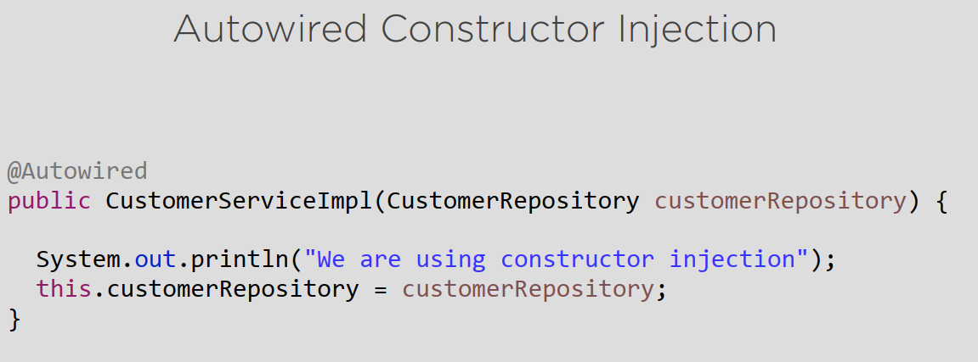

## Constructor Injection Demo

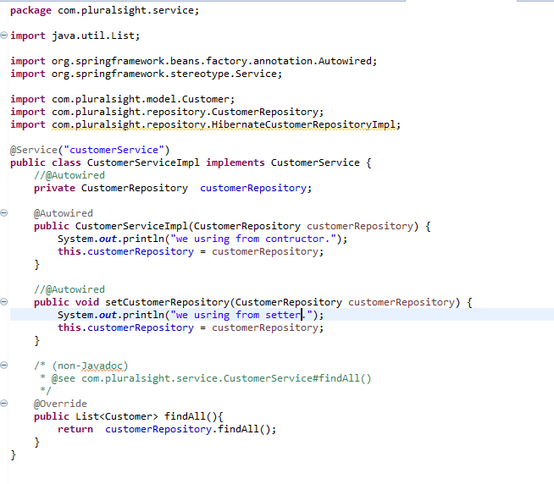

## JSR-330

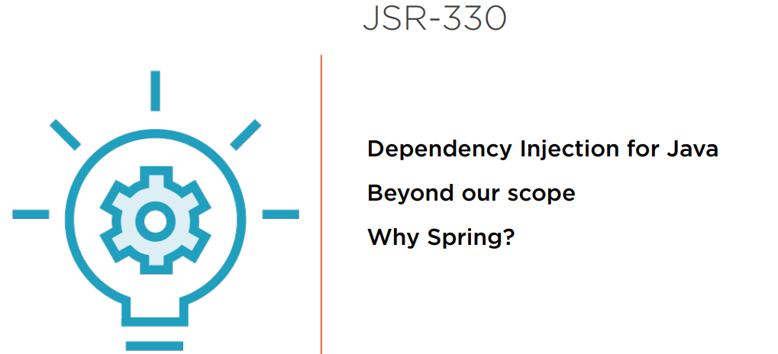

## Summary

# Spring Configuration Using Java

## Java Configuration Introduction

## Copy Demo

## AppConfig

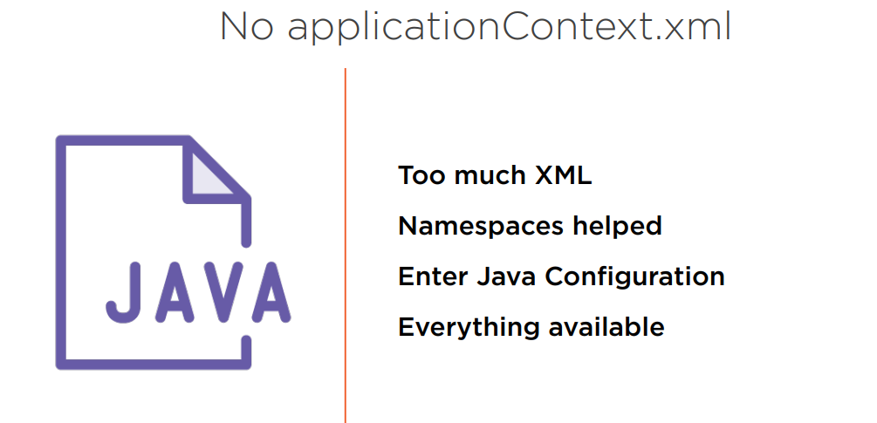

## AppConfig Demo

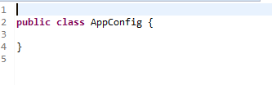

## @Configuration

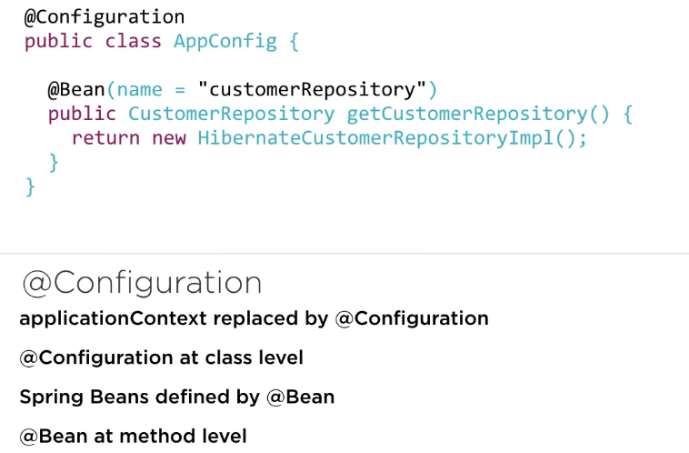

## @Configuration Demo

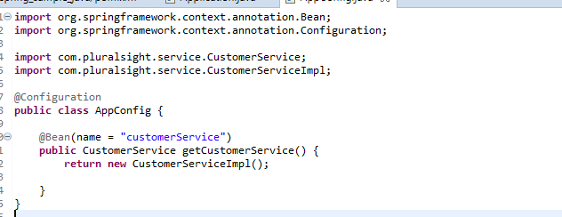

## Setter Injection

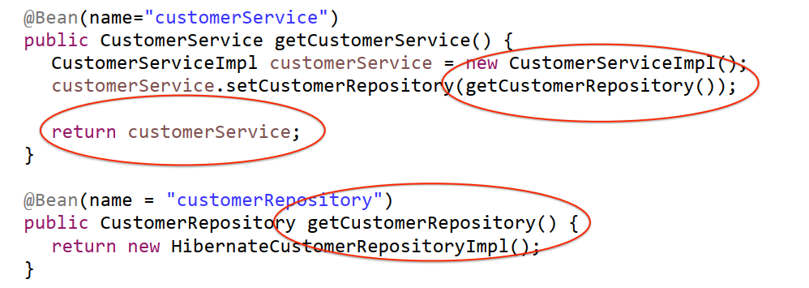

## Setter Injection Demo

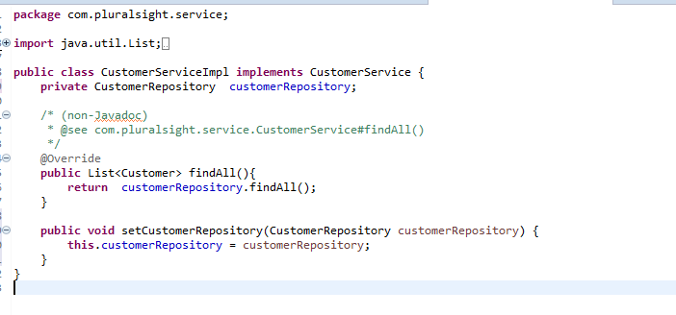

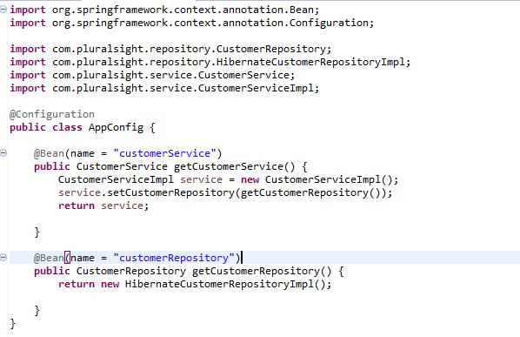

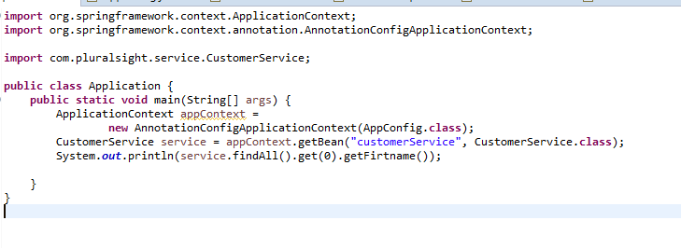

## Constructor Injection

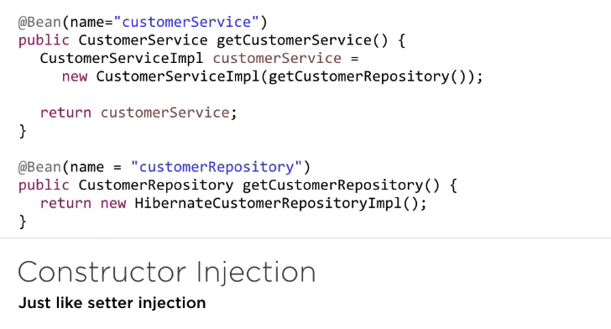

## Constructor Injection Demo

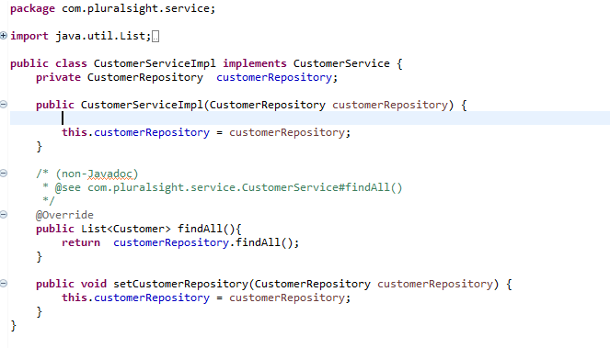

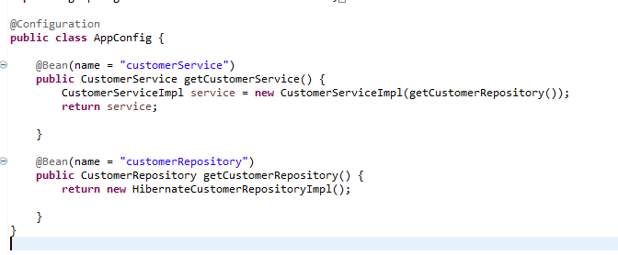

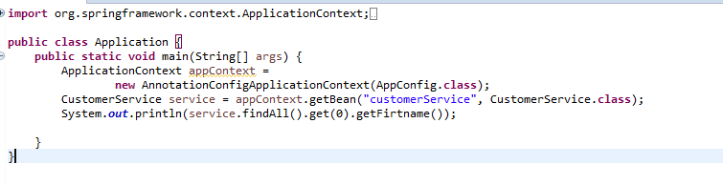

## Autowired

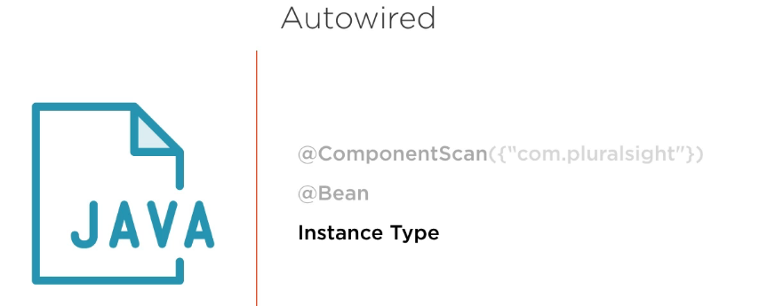

## Autowired Setup Demo

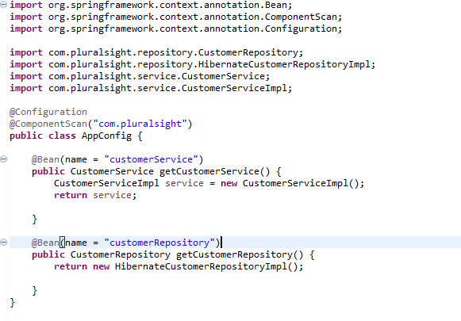

## Autowired Configuration Demo

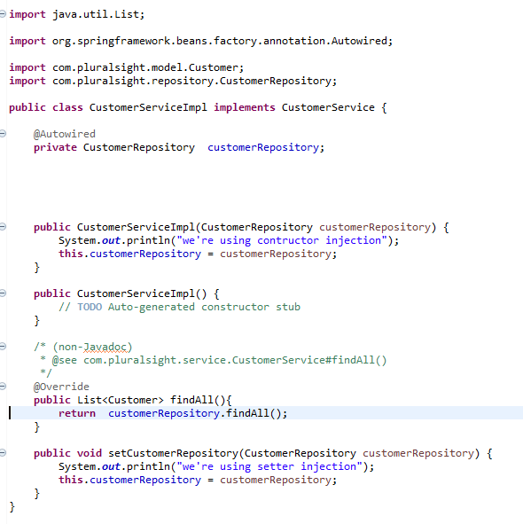

Can put Autowired before variable, setter injection, contructor injection.

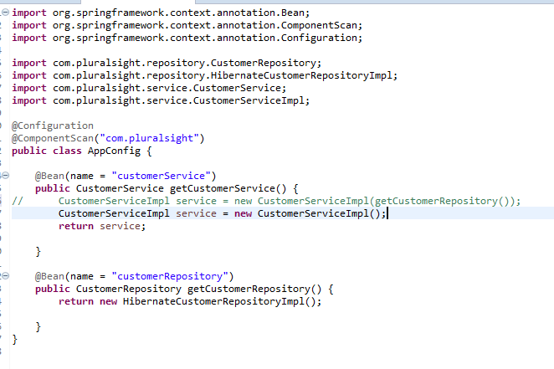

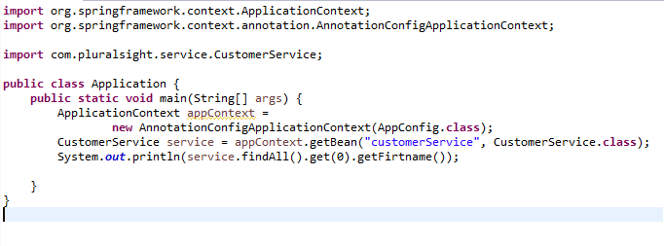

* Autowire

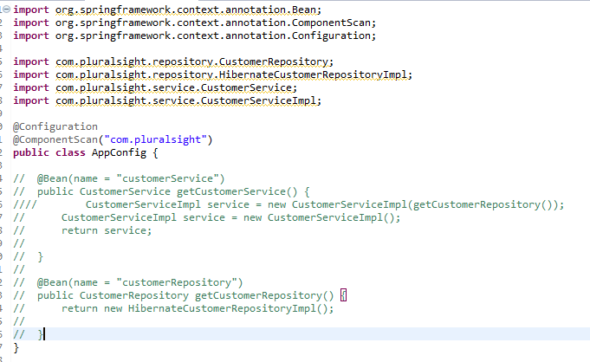

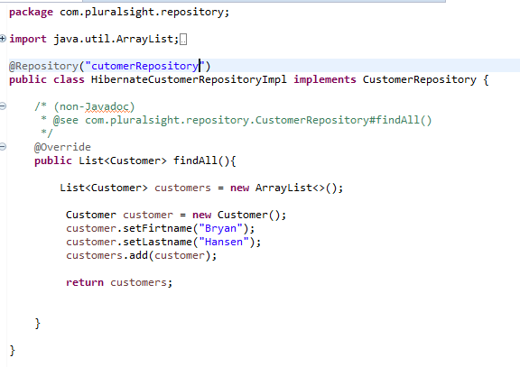

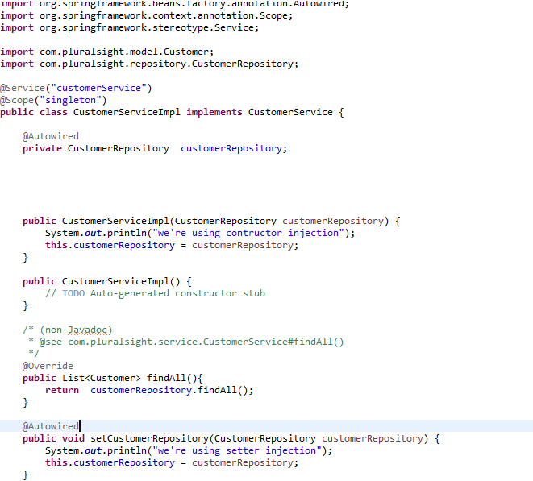

## Summary

# Bean Scopes

## Bean Scope Introduction

## Patterns



## Scopes

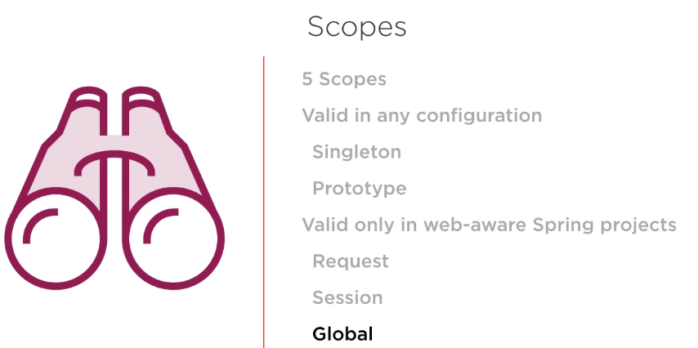

## Singleton

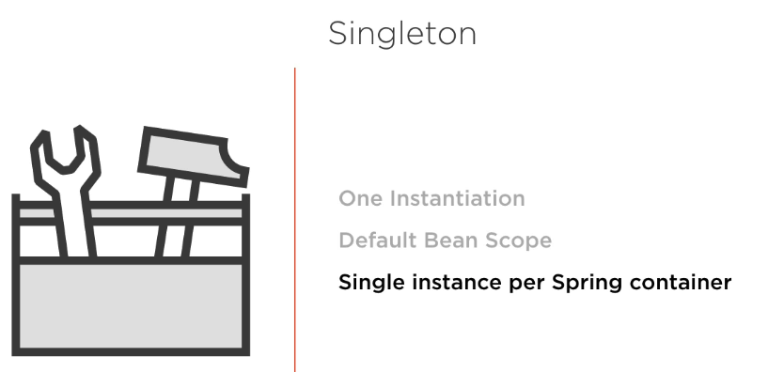

## Singleton Java Config

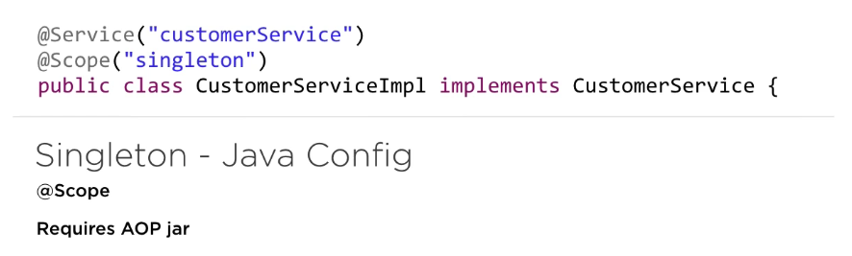

## Singleton Java Config Demo

## Singleton Java Config Using a Constant Demo

## Singleton XML Config

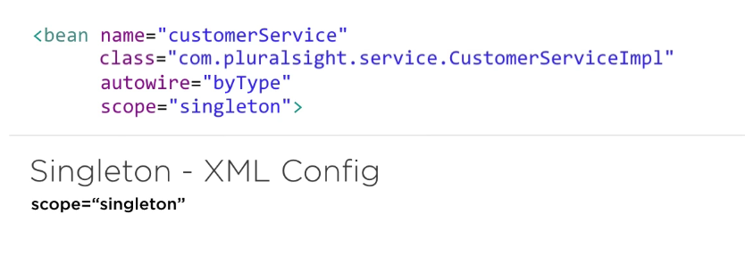

## Singleton XML Config Demo

## Prototype

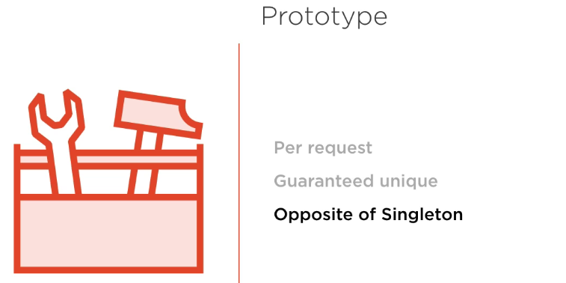

## Prototype XML Config Demo

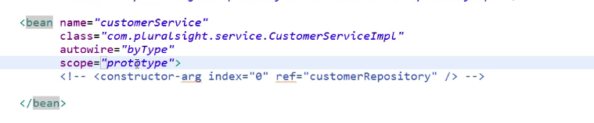

## Prototype Java Config Demo

## 

## Web Scopes

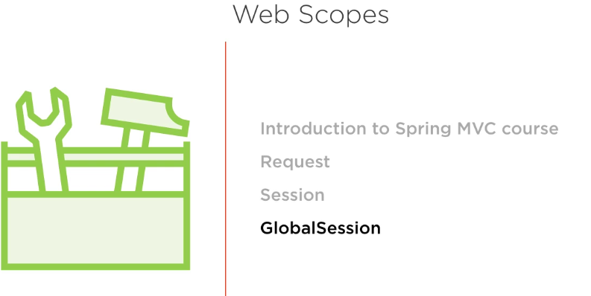

## Summary

# Properties

## Properties Introduction

## XML Config

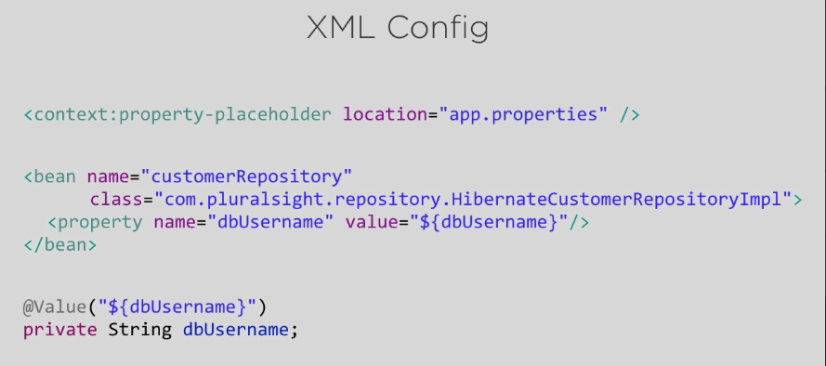

## XML Config Demo

Create app.properties

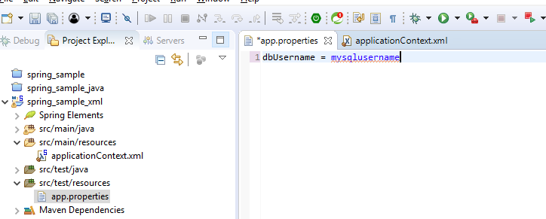

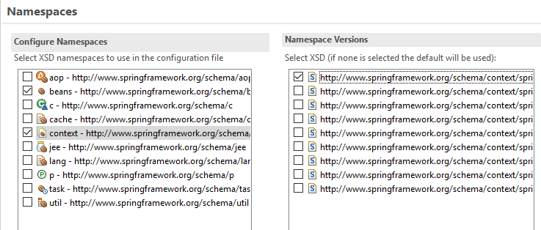

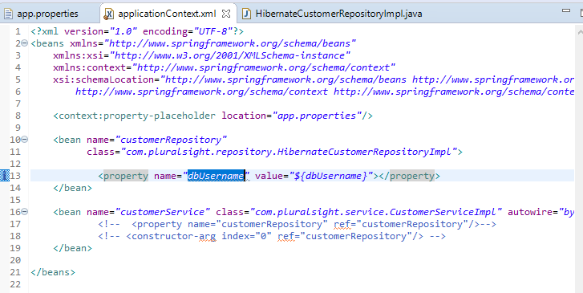

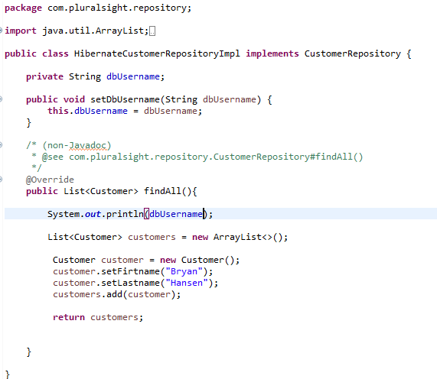

## XML Config Injection Demo

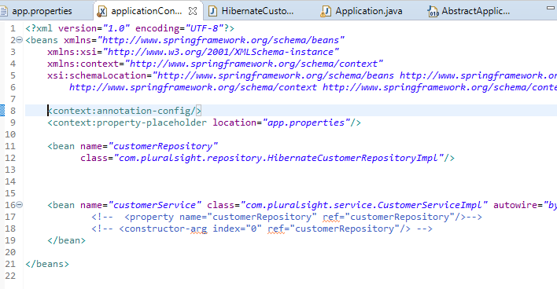

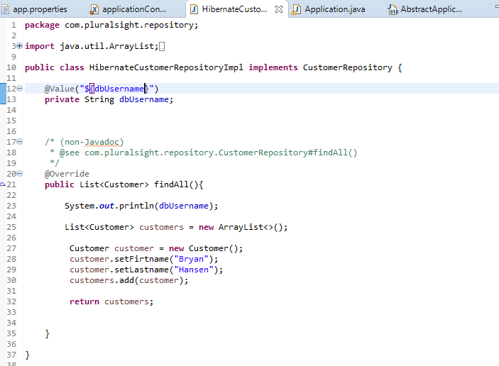

## Java Config

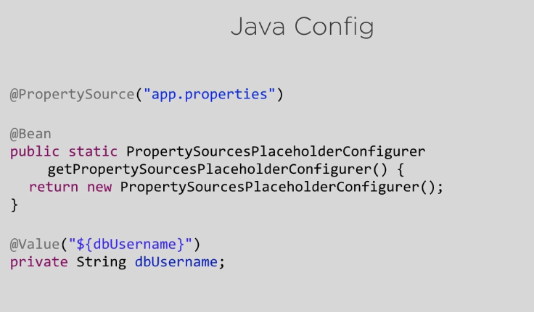

## Java Config Demo

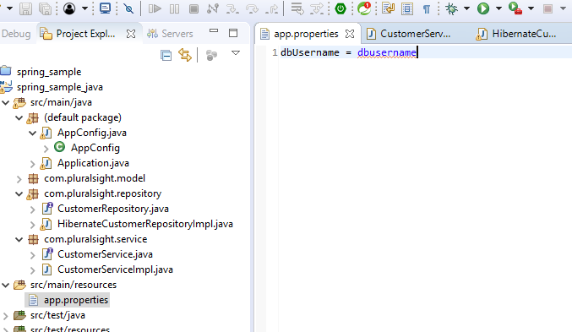

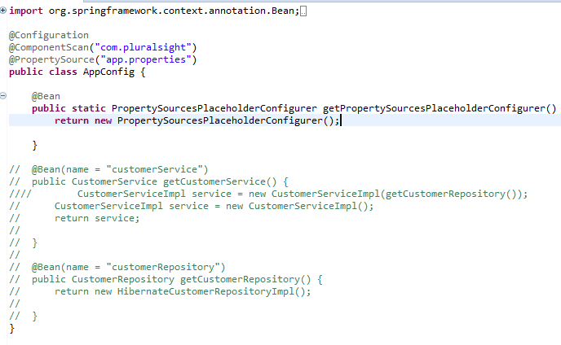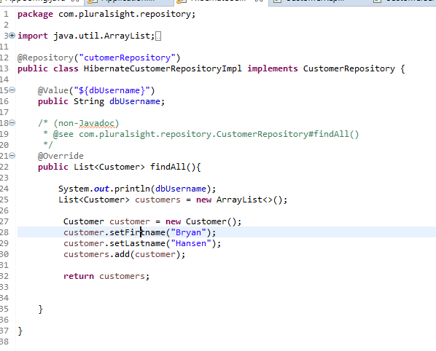

## Summary

# Next

## Next